**Project : Healthcare Telecommunication Systems**

* ***Phase 7: Integration & External Access***

1. ***Named Credentials***

**Purpose :** Store an endpoint URL and authentication in one place for secure callouts.

1. Setup → Named Credentials → New Named Credential
2. Enter: Label & Name
3. URL of the external system.
4. Identity Type: Named Principal (one login for all users) or Per User.
5. Authentication Protocol: Password Authentication or OAuth 2.0.
6. Save and use in Apex callouts as callout—no hard-coded URLs.

* ***External Credentials***

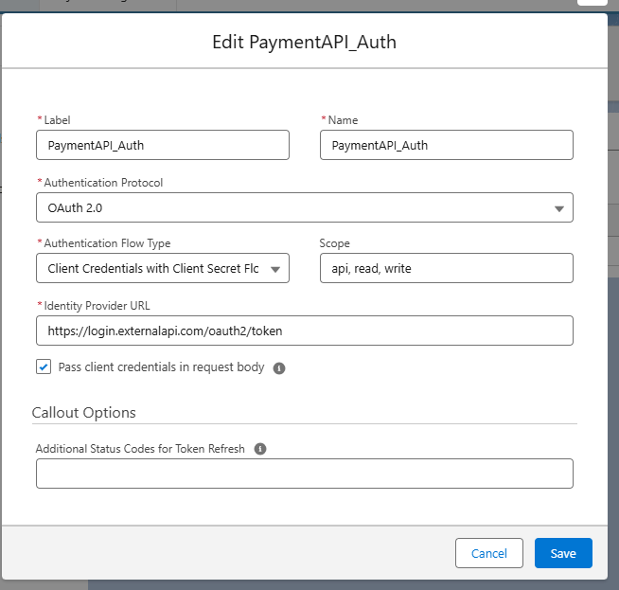

* ***Named Credentials***

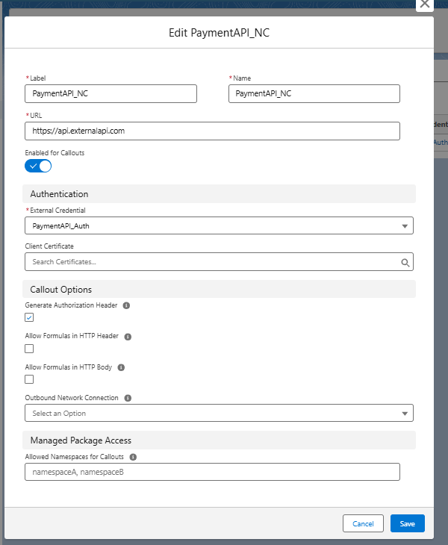

* ***Using Apex Class (Recommended for reuse)***

1. Go to Setup → Apex Classes → New
2. Enter a class name, e.g., PaymentAPIService
3. Paste the GET/POST code inside a method. Example:
4. Code :

public with sharing class PaymentAPIServiceAlt {

// GET Payment Details - returns response body

public static String getPayments() {

Http http = new Http();

HttpRequest req = new HttpRequest();

req.setEndpoint('callout:PaymentAPI_NC/v1/payments');

req.setMethod('GET');

try {

HttpResponse res = http.send(req);

System.debug('GET Status: ' + res.getStatusCode());

System.debug('GET Body: ' + res.getBody());

return res.getBody();

} catch (CalloutException e) {

System.debug('GET Callout Error: ' + e.getMessage());

return null;

}

}

// POST a Payment - returns response body

public static String createPayment(Decimal amount, String currencyCode) {

Http http = new Http();

HttpRequest req = new HttpRequest();

req.setEndpoint('callout:PaymentAPI_NC/v1/payments');

req.setMethod('POST');

req.setHeader('Content-Type', 'application/json');

// JSON body safely formatted

String requestBody = '{"amount":' + String.valueOf(amount) + ',"currency":"' + String.escapeSingleQuotes(currencyCode) + '"}';

req.setBody(requestBody);

try {

HttpResponse res = http.send(req);

System.debug('POST Status: ' + res.getStatusCode());

System.debug('POST Body: ' + res.getBody());

return res.getBody();

} catch (CalloutException e) {

System.debug('POST Callout Error: ' + e.getMessage());

return null;

}

}

// Optional: parse JSON response into a Map

public static Map<String, Object> parseJsonResponse(String jsonResponse) {

if(String.isBlank(jsonResponse)) return null;

try {

return (Map<String, Object>) JSON.deserializeUntyped(jsonResponse);

} catch (Exception e) {

System.debug('JSON Parse Error: ' + e.getMessage());

return null;

}

}

}

* Open **Developer Console → Execute Anonymous**, then run:

***Code :***

// GET payments

String getResponse = PaymentAPIServiceAlt.getPayments();

Map<String, Object> paymentsMap = PaymentAPIServiceAlt.parseJsonResponse(getResponse);

// POST a new payment

String postResponse = PaymentAPIServiceAlt.createPayment(200.75, 'USD');

Map<String, Object> postMap = PaymentAPIServiceAlt.parseJsonResponse(postResponse);

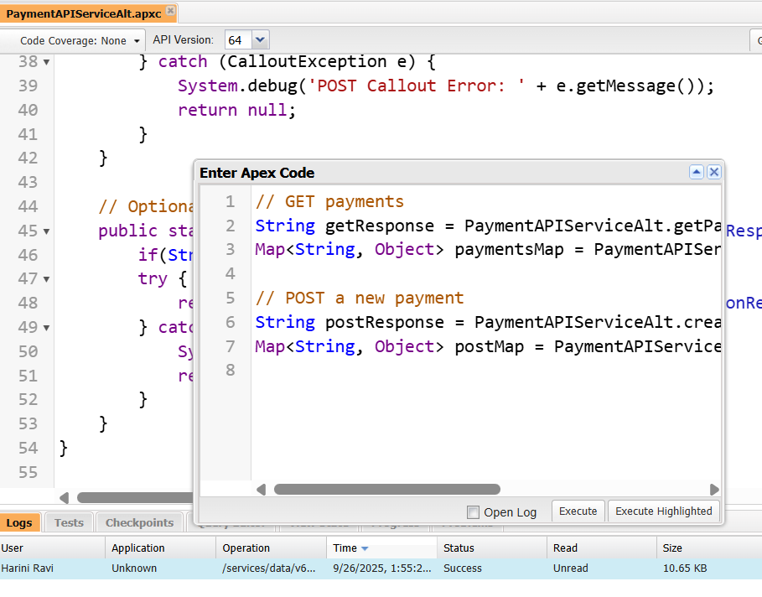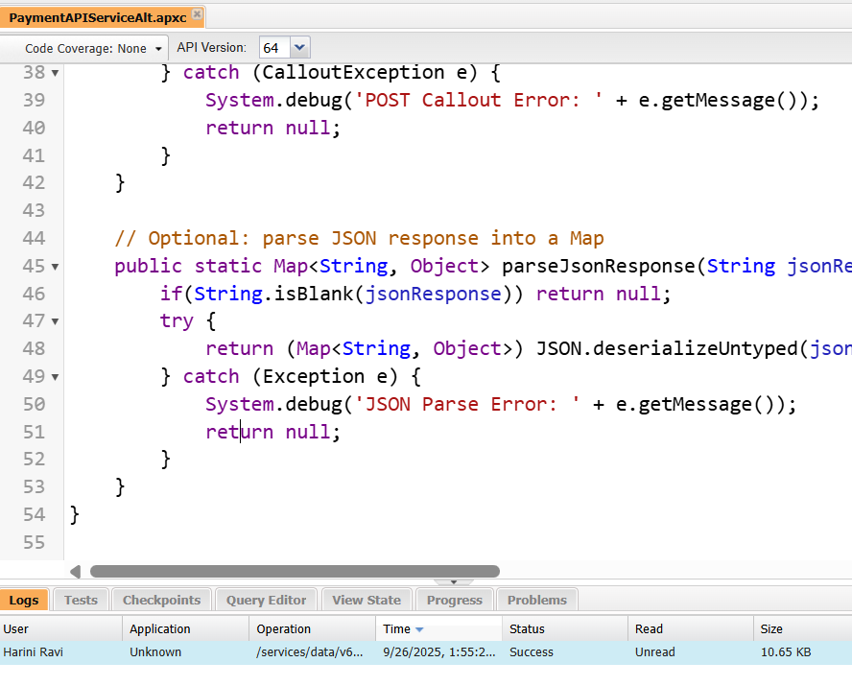

1. ***External Services***

**Purpose :** Declaratively connect Salesforce to REST APIs using Flows.

Steps:

1. Prepare a Swagger/OpenAPI spec of the external service.
2. Setup → External Services → New External Service
3. Fill in:

Name

Named Credential (from Step 1)

Swagger URL or file

1. Salesforce generates Apex actions for use in Flow Builder.
2. Usage: Drag actions into a Flow to call the external service without Apex code.
3. ***Web Services (REST/SOAP)***
4. Open Developer Console and Create Apex Class
5. Setup → Developer Console
6. File → New → Apex Class
7. Name it PaymentStatusAPI (or any valid name).

**Code :**

@RestResource(urlMapping='/PaymentStatus/*')

global with sharing class PaymentStatusAPI {

@HttpGet

global static Payment__c getPayment() {

RestRequest req = RestContext.request;

String paymentId = req.requestURI.substring(req.requestURI.lastIndexOf('/')+1);

Payment__c p = [SELECT Id, Name, Status__c, Amount__c, Appointment__r.Name

FROM Payment__c WHERE Id = :paymentId LIMIT 1];

return p;

}

@HttpPost

global static String createPayment(Payment__c newPayment) {

insert newPayment;

return 'Payment Created: ' + newPayment.Id;

}

}

